**Vaishali Pramod Fulzele**

C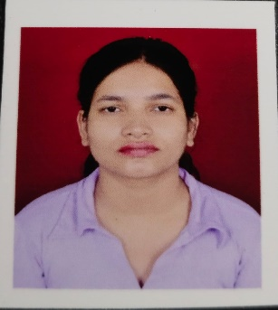

**Email id:** **aushreefulzele@gmail.com**

**Mobile:** 8080897287

# CAREER OBJECTIVE

To work in a challenging and dynamic environment to keep additional value to the organization, I am able to work under pressure Always looking for opportunities where I can improve my skills and progress professionally task and take an active part in company’s development.

# EDUCATION QUALIFICATIONS

|  |  |  |  |
| --- | --- | --- | --- |
| **Qualification** | **Institute** | **Year** | **SGPA/10/PER** |
| B.E | Rajiv Gandhi College of Engineering And  Research Nagpur | 2022 | 7.9 |
| DIPLOMA | Shree Datta Meghe Polytechnic Nagpur | 2019 | 60.88% |
| HSC | Baba Nanak Sindhi Hindi High School and Jr  College | 2016 | 54.46% |
| SSC | Baba Nanak Sindhi Hindi High School and Jr  College | 2014 | 67.60% |

**TECHNICAL QUALIFICATIONS**

**Programming:** JAVA, C, C++, MYSQL.

**Platform:**  Windows

**Web:** HTML, CSS, Basics of JS.

**PROJECT**

**TITLE:** ADVANCE DIGITAL VOICE ASSISTANT USING AI

**Description:** In this project we Collecting human voice from the mic, and convert voice into text using speech recognition library where speech recognition uses an Gaussian Mixture Model (GMM) algorithm and explore how this information could

be used to improve the user experience for doing their operations using voice.

**Technologies Used:** python, HTML, CSS power point presentation skills.

**WORK EXPERIENCE**

**Designation :** Executive Email Support

**Organization :** Valethi Technologies Full Time

**Duration :** April 2023 – July 2023

**INTERNSHIPS**

|  |
| --- |
| **Cojag Smart Technology Pvt. Ltd.**  (Duration February 2022 - March 2022)  **Description:** As a Part of this Web Development Internship, I have learned to create a website using HTML, CSS, PHP, and Python  **Skills used:** HTML,CSS,PHP,Python. |

**COURSES**

|  |  |
| --- | --- |
|  | **Centum Foundation She Arise 2.0 Program.**  (Duration October 2022-February 2023)  **Description:** As a part of this Full Stack Java Development Program, I have learned to work on Desktop Applications  **skills used:** JDBC, JPA+ HIBERNET, MYSQL, JAVA. |

# CO-CURRICULAR ACTIVITIES

* Participated in LUMINESCENCE a national level model making competition 2k18.
* Attended Virtual Workshop regarding Front End Development in Centum Foundation She arise 2.0 program.

# PERSONAL TRAITS

* Assertive.
* Adaptable.
* Driven and determined.
* Self-Motivated.

# PERSONAL PROFILE

* Name : Vaishali P. Fulzele
* Date of birth : May 15, 1999
* Father’s name : Pramod D. Fulzele
* Gender : Female
* Nationality : Indian
* Linguistic Abilities : English, Hindi, Marathi

**Place:** Nagpur